**Advanced Statistics (AS)**

A Project Report



BY

ABHISHEK K HIREMATH

|  |  |
| --- | --- |
| **Content** | **Page** |
| **Problem 1** | **5-6** |
| **1.1 What is the probability that a randomly chosen player would suffer an injury?** | **5** |
| **1.2 What is the probability that a player is a forward or a winger?** | **6** |
| **1.3 What is the probability that a randomly chosen player plays in a striker position and has a foot injury?** | **6** |
| **1.4 What is the probability that a randomly chosen injured player is a striker?** | **6** |
| **Problem 2** | **7-11** |
| **2.1 What proportion of the gunny bags have a breaking strength less than 3.17 kg per sq cm?** | **7-8** |
| **2.2 What proportion of the gunny bags have a breaking strength at least 3.6 kg per sq cm.?** | **8-9** |
| **2.3 What proportion of the gunny bags have a breaking strength between 5 and 5.5 kg per sq cm.?** | **9-10** |
| **2.4 What proportion of the gunny bags have a breaking strength NOT between 3 and 7.5 kg per sq cm.?** | **10-11** |
| **Problem 3** | **12-14** |
| **3.1 Zingaro has reason to believe that the unpolished stones may not be suitable for printing. Do you think Zingaro is justified in thinking so?** | **13** |
| **3.2 Is the mean hardness of the polished and unpolished stones the same?** | **14** |
| **Problem 4** | **14-25** |
| **4.1 How does the hardness of implants vary depending on dentists?** | **14-17** |
| **4.2 How does the hardness of implants vary depending on methods?** | **18-20** |
| **4.3 What is the interaction effect between the dentist and method on the hardness of dental implants for each type of alloy?** | **20-22** |
| **4.4 How does the hardness of implants vary depending on dentists and methods together?** | **22-25** |

**List of Tables:**

|  |  |  |
| --- | --- | --- |
| **No** | **Name Of Table** | **Page No** |
| **1** | **Physiotherapist Table** | **5** |
| **2** | **Interaction Table for Alloy 1** | **23** |
| **3** | **Interaction Table for Alloy 2** | **24** |

**List Of Figures:**

|  |  |  |
| --- | --- | --- |
| **No** | **Name Of Figures** | **Page No** |
| **1** | **Breaking Strength and Probability Distribution-1** | **8** |
| **2** | **Breaking Strength and Probability Distribution-2** | **9** |
| **3** | **Breaking Strength and Probability Distribution-3** | **10** |
| **4** | **Breaking Strength and Probability Distribution-4** | **11** |
| **5** | **Zingaro Data** | **12** |
| **6** | **Zingaro Data info** | **12** |
| **7** | **Shapiro Wilk’s Test Result for Dentist** | **14** |
| **8** | **Anova For Alloy-1(Dentist)** | **15** |
| **9** | **Anova For Alloy-2(Dentist)** | **15** |
| **10** | **Andreson Darling Test for Alloy-1** | **16** |
| **11** | **Andreson Darling Test for Alloy-2** | **16** |
| **12** | **Box plot For Dentist and Alloy** | **17** |
| **13** | **Point plot For Dentist and Alloy** | **17** |
| **14** | **Shapiro Wilk’s Test Result for Method** | **18** |
| **15** | **Anova For Alloy-1(Method)** | **18** |
| **16** | **Anova For Alloy-2(Method)** | **18** |
| **17** | **Tukey's multiple comparison test forAlloy-1** | **19** |
| **18** | **Tukey's multiple comparison test forAlloy-2** | **19** |
| **19** | **Box and Hist plot for Method** | **20** |
| **20** | **Point plot for Method** | **20** |
| **21** | **Tow-way Anova Test for Dentist and Method (Alloy-1)** | **21** |
| **22** | **Point plot for Dentist Alloy-1** | **21** |
| **23** | **Tow-way Anova Test for Dentist and Method (Alloy-2)** | **21** |
| **24** | **Point Plot for Dentist Alloy-2** | **22** |
| **25** | **Two-way Anova Test for Alloy1(Temp)** | **22** |
| **26** | **Two-way Anova Test for Alloy1(Method and Dentist)** | **23** |
| **27** | **Two-way Anova Test for Alloy2(Temp)** | **23** |
| **28** | **Two-way Anova Test for Alloy2(Method and Dentist)** | **24** |
| **29** | **Interaction Plot 1** | **24** |
| **30** | **Interaction plot 2** | **25** |

**Problem-1**

A physiotherapist with a male football team is interested in studying the relationship between foot injuries and the positions at which the players play from the data collected.

|  |  |  |  |  |  |
| --- | --- | --- | --- | --- | --- |
|  | Striker | Forward | Attacking Midfielder | Winger | **Total** |
| Players Injured | 45 | 56 | 24 | 20 | **145** |
| Players Not Injured | 32 | 38 | 11 | 9 | **90** |
| **Total** | **77** | **94** | **35** | **29** | **235** |

**Table: -1**

* 1. What is the probability that a randomly chosen player would suffer an injury?

**Solution:** Probability that a randomly chosen player would suffer an injury

= Total Number of Players Injured/ Total Number of Players

= 145/235

= **0.62.**

Probability that a randomly chosen player would suffer an injury is **0.617**

**1.2** What is the probability that a player is a forward or a winger?

**Solution:** Probability that a player is a forward or a winger

= (Number of Forwards + Number of Wingers) */ Total Number of Players

= (94+29)/235

= **0.52.**

Probability that player is a forward or a winger **0.5234**

**1.3** What is the probability that a randomly chosen player plays in a striker position and has a foot injury?

**Solution:** Probability that a randomly chosen player plays in a striker position a foot injury

= Number of Injured Strikers/ Total Number of Players

= 45/235

= **0.19.**

Probability that randomly chosen player plays in a striker position and has a foot injury **= 0.191**

**1.4** What is the probability that a randomly chosen injured player is a striker?

**Solution:** Probability that a randomly chosen injured player is a striker

= Number of Injured Strikers/ Total Number of Injured Players

= 45/145

= **0.31.**

Probability that randomly chosen injured player is a striker **= 0.310**

**Problem-2**

The breaking strength of gunny bags used for packaging cement is normally distributed with a mean of 5 kg per sq. centimeter and a standard deviation of 1.5 kg per sq. centimeter. The quality team of the cement company wants to know the following about the packaging material to better understand wastage or pilferage within the supply chain.

Mean = **5 kg per sq. centimeter = mu**

Standard deviation = **1.5 kg per sq. centimeter = sigma**

The breaking strength of gunny bags used for packaging cement is **normally distributed**

**2.1** What proportion of the gunny bags have a breaking strength less than 3.17 kg per sq cm?

**Solution:** Here as per the problem statement we have

X = 3.17, μ = 5, σ = 1.5

Let us calculate the Z score & p value corresponds to it:

**Z score = x - μ/ σ**

Z-score= (3.17 - 5)/ 1.5 = -1.22

P-value from Z-Table:

P(x<3.17) = 0.11123

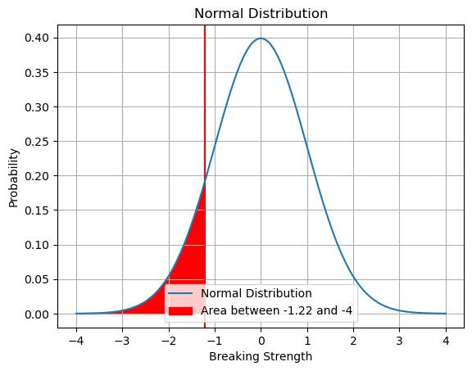

**Fig: -1**

**Hence as per the p value, 11.12 % of the gunny bags have a breaking strength less than 3.17 kg per sq cm.**

**2.2** What proportion of the gunny bags have a breaking strength at least 3.6 kg per sq. cm?

**Solution:** Here as per the problem statement we have

X = 3.6, μ = 5, σ = 1.5

Let us calculate the Z score & p value corresponds to it:

**Z score = x - μ/ σ**

Z-score = (3.6 - 5)/ 1.5

= -0.9333

P-value from Z-Table:

P(x>3.6) = 1 - P(x<3.6) = 0.8247

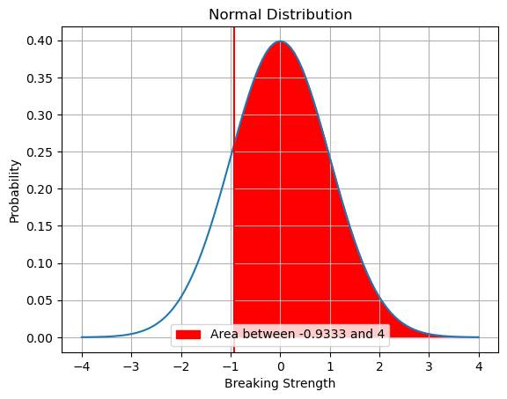

**Fig: -2**

**Hence as per the p value, 82.47% of the gunny bags have a breaking strength at least 3.6 kg per sq cm.**

**2.3** What proportion of the gunny bags have a breaking strength between 5 and 5.5 kg per sq cm.?

**Solution:** Here as per the problem statement we have

X = 5.5, μ = 5, σ = 1.5

Let us calculate the Z score & p value corresponds to it:

Z score = x - μ/ σ

Z-score = (5.5 - 5)/ 1.5

= 0.33333

P-value from Z-Table:

P(5<x<5.5) = P(x<5.5) - 0.5 = 0.13056

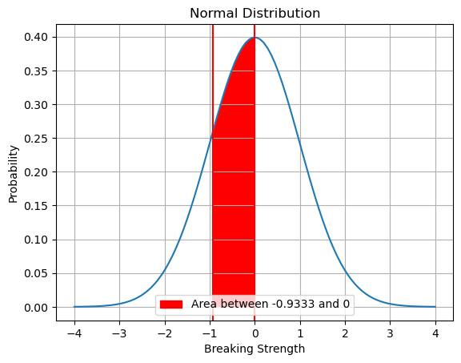

**Fig: -3**

**2.4** What proportion of the gunny bags have a breaking strength NOT between 3 and 7.5 kg per sq cm.?

**Answer:** Here as per the problem statement we have

X = 3 & 7.5, μ = 5, σ = 1.5

Let us calculate the Z score & p value corresponds to it:

Z score when x is 3

Z score = x - μ/σ

=3 - 5 / 1.5

= -1.33333

P-value from Z-Table:

P(x>3) = 1 - P(x<3) = 0.90879

Z score when x is 7.5

Z score = x - μ/σ

=7.5 - 5 / 1.5

= 1.66667

P-value from Z-Table:

P(x>7.5) = 1 - P(x<7.5) = 0.04779

P-value = 0.04779+ 0.091211

= 0.139001

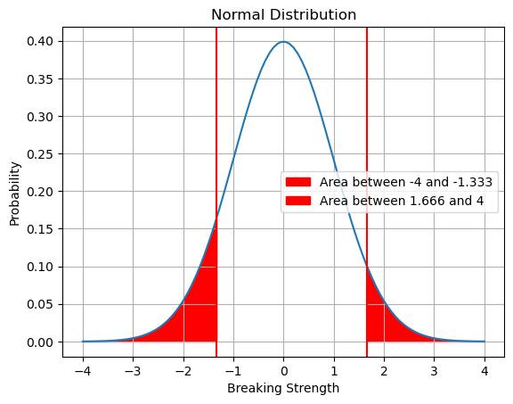

**Fig: -4**

**Hence as per the p value, 13.90% of the gunny bags have a breaking strength NOT between 3 and 7.5 kg per sq cm.**

**Problem-3**

Dataset - [Link](https://olympus.mygreatlearning.com/courses/84254/files/6908101/download?verifier=Mg4gqJnhQEpxN5lnavpfA1ebE4rIyJBPLZzTWLTC&wrap=1)

Zingaro stone printing is a company that specializes in printing images or patterns on polished or unpolished stones. However, for the optimum level of printing of the image the stone surface has to have a Brinell's hardness index of at least 150. Recently, Zingaro has received a batch of polished and unpolished stones from its clients. Use the data provided to answer the following (assuming a 5% significance level);

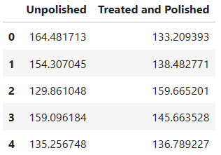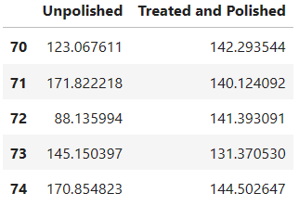

**Fig: -5**

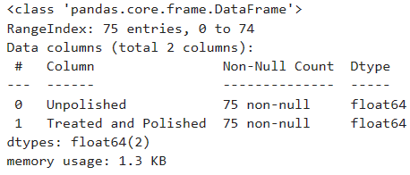

**Fig: -6**

**3.1** Zingaro has reason to believe that the unpolished stones may not be suitable for printing. Do you think Zingaro is justified in thinking so?

**Solution:** First, hypothesizing for unpolished stones, we have:

**H0**= Zingaro believes now that the unpolished stones may suitable for printing

**H1**= Zingaro believes now that the unpolished stones may suitable for printing

Step1: Ho (Null Hypothesis) -> Sample Mean >=150

H1 (Alternate Hypothesis) -> Sample Mean <150

Step2: Given, alpha = 0.05

Step 3: 1 sample z-test as this is a one-sided sample with **sample size is 75>30**

Step 4: mu = 150 and n=75(Sample size).

Degrees of Freedom =75-1=74, since the sample size for both samples are the same.

Also, **mu** unpolished= 134.11, **Sigma** unpolished = 33.04, **mu** polished= 147.79, **Sigma** polished = 15.59.

One sample t test

t statistic: -4.171286997419652e-05, p value: 8.342573994839304e-05

Step 5: p-value for unpolished~0 < 0.05 (i.e. alpha) and hence Null Hypothesis is rejected in that case. **So, unpolished stones do not have a Brinell's hardness index of at least 150.** Whilst, in case of treated and polished p-value is 0.11 > 0.05 (i.e. alpha) and hence Null Hypothesis cannot be rejected in that case. **So, treated, and polished stones have a Brinell's hardness index of at least 150.**

**INSIGHTS:**Since, the null hypothesis is rejected. At 5% significance level, there is enough evidence to make conclusion that the unpolished stones are not suitable for printing and his claim is justified.

**3.2** Is the mean hardness of the polished and unpolished stones the same?

**Solution:** H0= Mean hardness of the polished and unpolished stones is same

H1= Mean hardness of the polished and unpolished stones is not same

Test: Two-tailed t-test, Also, **mu** unpolished= 134.11, **Sigma** unpolished = 33.04, **mu** polished= 147.79, **Sigma** polished = 15.59 and n =75.

The p-value of the two-tailed test is 0.0014655150194628353 and is significantly less than 0.05 (i.e. alpha), so alternate hypothesis prevails.

**INSIGHTS:** Hence, the hardness of polishes and unpolished stones are significantly different. Since, the null hypothesis is rejected. At 5% significance level, there is insufficient evidence to conclude that the mean hardness of the polished and unpolished stones are not the same.

**Problem-4**

Dental implant data: The hardness of metal implants in dental cavities depends on multiple factors, such as the method of implant, the temperature at which the metal is treated, the alloy used as well as the dentists who may favor one method above another and may work better in his/her favorite method. The response is the variable of interest.

**4.1** How does the hardness of implants vary depending on dentists?

**Solution:** The Hypothesis for the One Way ANOVA are:

H0: There is difference among Dentists on implant hardness

Ha: There is no difference among Dentists on implant hardness

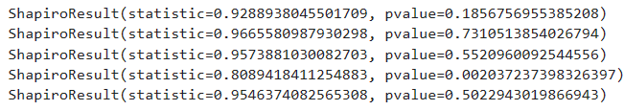

**Fig: -7**

From the **Wilk’s test**: The Test Statistic value is 0.808 and P-value is 0.00203

Conclusion: We can conclude that P-value is 0.002037 (<<0.05), so we have enough evidence to Reject Null Hypothesis and consider that the sample drawn for Alloy 1 does not follow a normal distribution

Hypothesis 1

Ho: The mean hardness of dental implant is same for dentists provided the alloy 1 is used.

Ha: for at least 1 dentist the mean Hardness of Dental implant is different when using Alloy1.

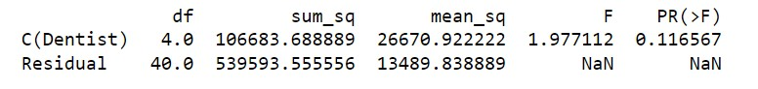

**Fig: -8**

P-value is 0.11 which is greater than alpha i.e., 0.05. Hence, we Fail to reject null hypothesis and consider there is no difference in means among the dentists in terms of implant hardness for Alloy 1.

Hypothesis 2

Ho: The mean Hardness of Dental implant is same dentists provided the Alloy 2 is used.

Ha: for at least 1 dentist the mean Hardness of Dental implant is different when using Alloy 2.

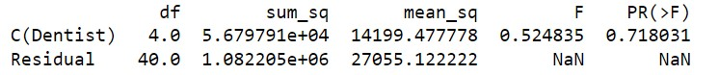

**Fig: -9**

P-value is 0.71 which is greater than alpha i.e., 0.05. Hence, we Fail to reject null hypothesis and consider there is no difference in means among the dentists in terms of implant hardness for Alloy 2

After performing one-way Anova on each Alloy, we found p value:

For Alloy 1: 0.116567, For Alloy 2: 0.718031

Hence at p - value > 0.05, we fail to Reject H0. i.e., at 95 % confidence we have statistical evidence to state that there is no difference among the Dentists on implant hardness.

**For Alloy 1** - Anderson-Darling Normality Test gives following results-



**Fig: -10**

The test statistic is 2.56 We can compare this value to each critical value that corresponds to each significance level to see if the test results are significant.

The critical value for α = 0.025 is 0.853. Because the test statistic (2.56) is greater than this critical value, the results are significant at a significance level of 0.025.

Same is the case with all the other values-

We can see that the test results are significant at every significance level, which means we would reject the null hypothesis of the test no matter which significance level we choose to use. Thus, we have sufficient evidence to say that the sample data is not normally distributed.

**For Alloy 2** - Anderson-Darling Normality Test gives following results-



**Fig: -11**

The test statistic is 1.89 We can compare this value to each critical value that corresponds to each significance level to see if the test results are significant.

The critical value for α = 0.025 is 0.853. Because the test statistic (1.89) is greater than this critical value, the results are significant at a significance level of 0.025.

Same is the case with all the other values: -

We can see that the test results are significant at every significance level, which means we would reject the null hypothesis of the test no matter which significance level we choose to use. Thus, we have sufficient evidence to say that the sample data is not normally distributed.

* Both the distributions are not normally distributed, which violates the assumptions.
* Considerable presence of out liars could also be seen for both alloys, and ANOVA is sensitive to Outliers.

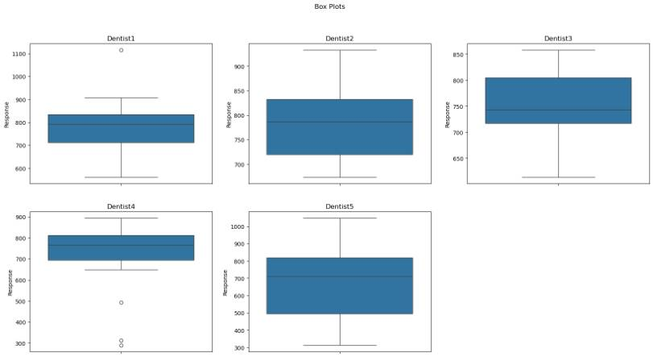

**Fig: -12**

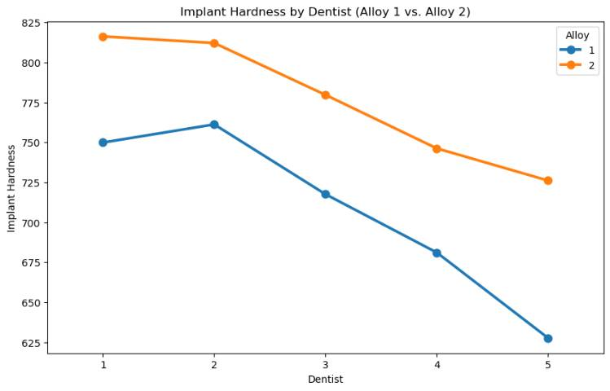

**Fig: -13**

**4.2** How does the hardness of implants vary depending on methods?

**Solution:** The Hypothesis for the One Way ANOVA are:

H0: There is difference with Method on implant hardness

Ha: There is no difference with Method on implant hardness

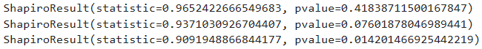

**Fig: -14**

From the Wilk test: The Test Statistic value is 0.937 and P-value is 0.0760

Hypothesis Test for Alloy 1 data

* Null hypothesis (for Alloy 1): There is no difference in means among the Methods in terms of implant hardness for Alloy1.
* Alternative hypothesis (for Alloy 1): There is a difference in means among the Methods in terms of implant hardness for Alloy 1

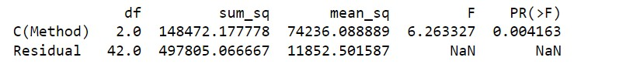

**Fig: -15**

P-value is 0.004 which is lesser than alpha i.e., 0.05. Hence, we have enough evidence to reject null hypothesis and consider there is a difference in means among the Methods in terms of implant hardness for Alloy 1.

Hypothesis Test for Alloy 2 data

* Null hypothesis (for Alloy 2): There is no difference in means among the Methods in terms of implant hardness for Alloy2.
* Alternative hypothesis (for Alloy2): There is a difference in means among the Methods in terms of implant hardness for Alloy2.

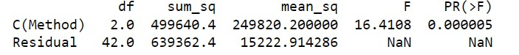

**Fig: -16**

P-value is 0.000005 which is lesser than alpha i.e., 0.05. Hence, we have enough evidence to reject null hypothesis and consider there is a difference in means among the Methods in terms of implant hardness for Alloy 2.

As we have rejected the null hypothesis for both the alloys, let us check for which methods the mean implant hardness is significantly different.

We can use Tukey's multiple comparison test for this-

**For Alloy 1 –**

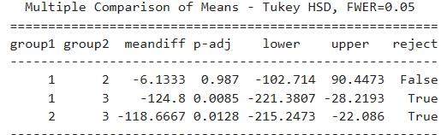

**Fig: -17**

Mean difference for method 3 is quite high when compared with both methods 1 & 2**.**

Tukey’s HSD Test for multiple comparisons found that the mean implant hardness was significantly different between Method 1 and Method 3 it is different for Method 2 and Method 3 as well.

**For Alloy 2-**

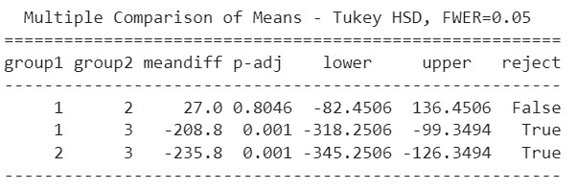

**Fig: -18**

Mean difference for method 3 is quite high when compared with both methods.

Tukey’s HSD Test for multiple comparisons found that the mean implant hardness was significantly different between Method 1 and Method 3 it is different for Method 2 and Method 3 as well.

After performing one-way Anova on each Alloy, we found p value:

For Alloy 1: 0.004163, For Alloy 2: 0.000005

Hence at p - value < 0.05, we accept H0, i.e., At 95 % confidence we have statistical evidence to state that there is difference among the method used on implant hardness

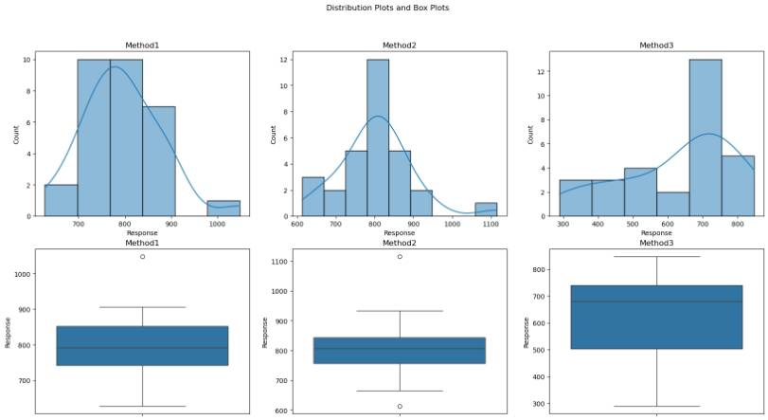

**Fig: -19**

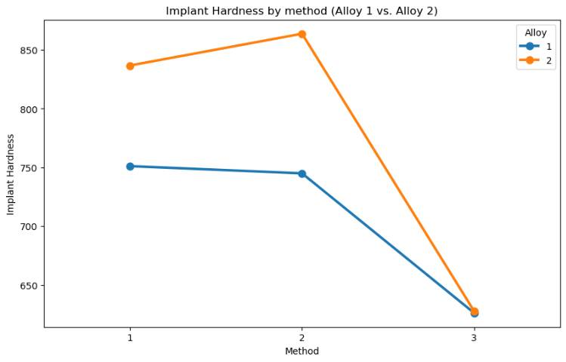

**Fig: -20**

**4.3** What is the interaction effect between the dentist and method on the hardness of dental implants for each type of alloy?

**Solution:** Define null and alternative hypothesis

* Null hypothesis (H0): There is no difference among the Interaction effect between Dentist and Method levels in terms of implant hardness
* Alternative hypothesis (Ha): There is a difference among the Interaction effect between Dentist and Method levels in terms of implant hardness

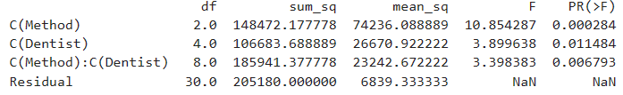

**Fig: -21**

For, the method and dentist P-value is 0.006793 which is lesser than alpha i.e., 0.05. Hence, we have enough evidence to reject null hypothesis and consider there is a difference in means among the Interaction effect between Dentist and Method levels in terms of implant hardness for Alloy 1.

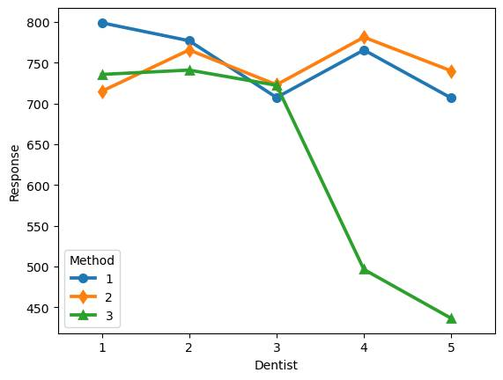

**Fig: -22**

**Note:** It could be noticed that there is interaction between dentist and method feature.

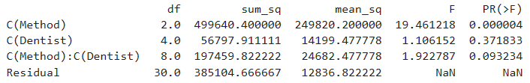

**Fig: -23**

As p-value (0.09323) > alpha (0.05)

We failed to reject the null hypothesis. As there is no significant interaction between Dentist and Method considering only alloy 2.

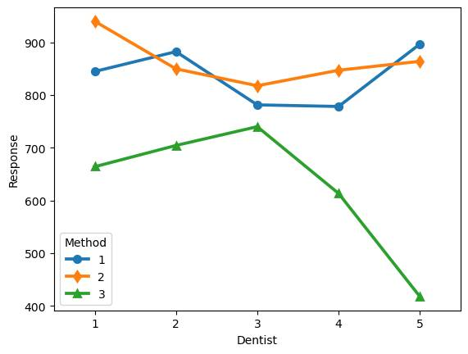

**Fig: -24**

**Note:** There is no as such significant interaction between method 3 and dentist feature for alloy 2. As the method 1 and method 2 has the interaction in between.

**4.4** How does the hardness of implants vary depending on dentists and methods together?

**Solution:** Hypothesis Test alloy1

* Null hypothesis (H0): There is no difference among the factors Dentist and Method levels in terms of implant hardness.
* Alternative hypothesis (Ha): There is a difference among the factors Dentist and Method levels in terms of implant hardness

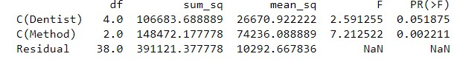

**Fig: -25**

P value for Method is 0.0022 which is less than 0.05. Hence, we have enough evidence to reject null hypothesis and consider that at least one pair of Method means is different for Alloy 1.

Calculate two-way anova for interaction between dentist and method **For alloy 1**:

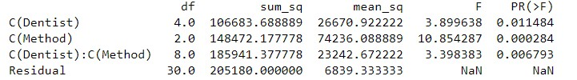

**Fig: -26**

P value for Dentist, Method, and Interaction variable (Dentist: Method) are all less than 0.05. Hence, we can conclude that to reject null hypothesis and consider there is at least one pair of variables means are different for Alloy 1.

Considering alpha= 0.05

|  |  |
| --- | --- |
| Interaction | p-value |
| Dentist- Method | 0.006793 |
| Dentist- Temp | 0.862862 |
| Method –Temp | 0.898357 |

**Table: -2**

Only the interaction between Dentist and Method is significant. Other then there is no significant interaction between variables for alloy 1.

Hypothesis Test for Alloy 2

* Null hypothesis H0 (for Alloy 2): There is no difference among the factors Dentist and Method levels in terms of implant hardness for Alloy 2.
* Alternative hypothesis Ha (for Alloy 2): There is a difference among the factors Dentist and Method levels in terms of implant hardness for Alloy 2.

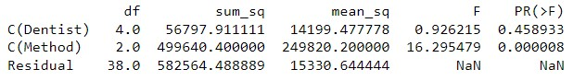

**Fig: -27**

P value for Method is 0.000008 which is less than 0.05. Hence, we have enough evidence to reject null hypothesis and consider that at least one pair of Method means is different for Alloy 2

Calculate two-way Anova for interaction between dentist and method **For alloy 2**:

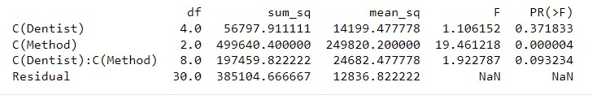

**Fig: -28**

Considering alpha= 0.05

|  |  |
| --- | --- |
| Interaction | p-value |
| Dentist- Method | 0.093234 |
| Dentist- Temp | 0.825318 |
| Method –Temp | 0.675983 |

**Table: -3**

There is no significant interaction between variables for alloy 2.



**Fig: -29**

With above interaction plot, we can conclude that:

* Method 1 & Method 2 has interaction among them. While Method 3 has no interactions with others.

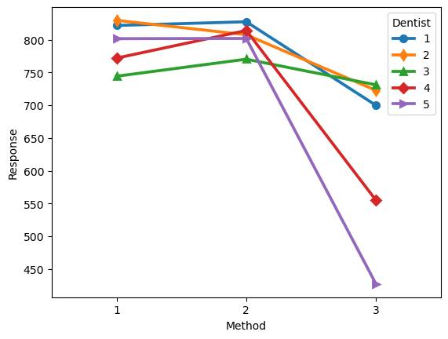

**Fig: -30**

We can see that there is some sort of interaction between the Methods used.

END